Report

Angus and Riyaad

This report is made to report on the work that we could not document on Github due to our issues with the platform as well as to show the progress of building the project and to show proof of our team efforts.

git hub and pushing our changes as it would always try to merge after giving a failed to push error, thus we just decided on uploading to a discord server and adding comments to indicate who did what. This was our next best option, as a substitute for Github and which we both agreed on.

Angus’s discord username was Za Neko and Riyaad’s Discord username was infinite. A majority of the reports on the code we worked on previously before these instances and were lost due to Github. Some of this work included code for the save buttons and check boxes. It should also be taken into account that there were instances where we worked over a live session which is a feature in Visual Studios which allows us to code on the same project at the same time.

Contents

Report 1

Angus and Riyaad 1

First Build 2

Second Build 4

Third and Fourth Build 5

Fifth Build 5

## First Build

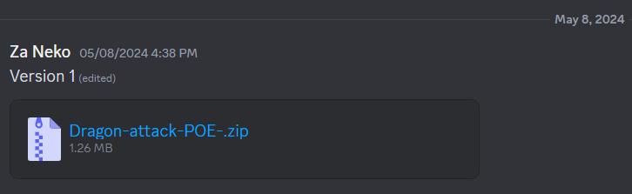

This was the work that was completed for the build

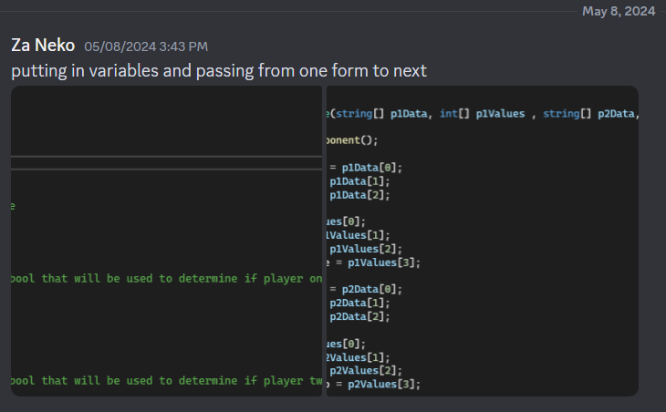

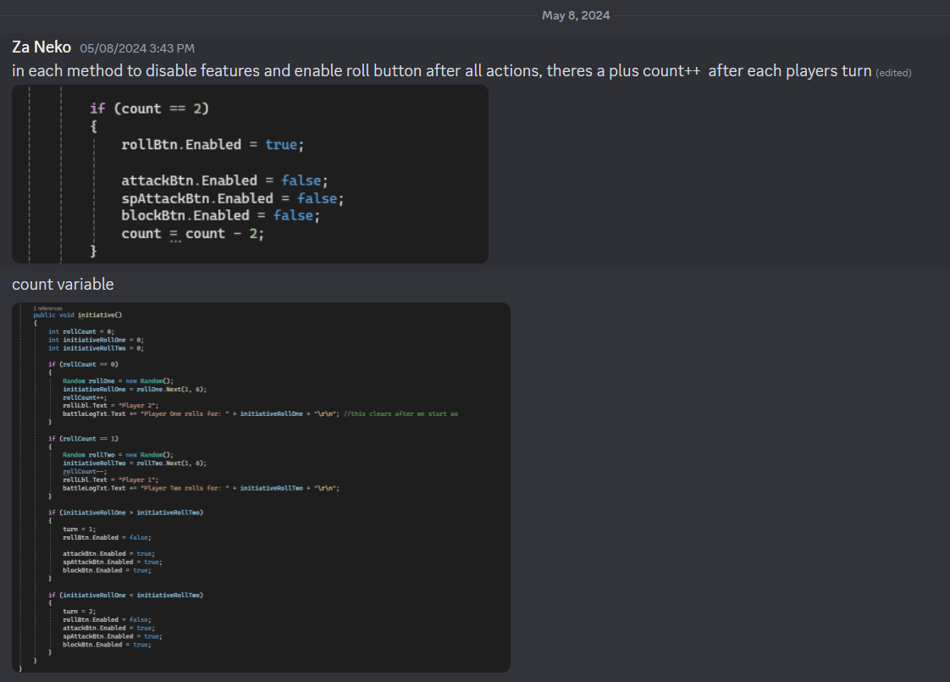

## Second Build

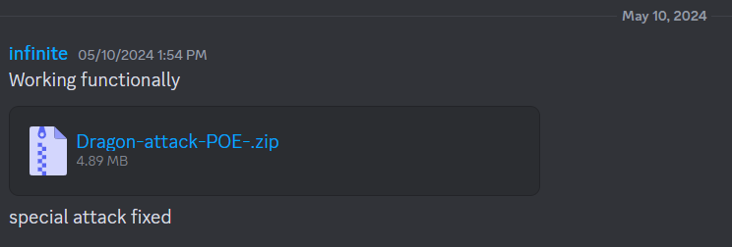

This was the work that was completed for the build

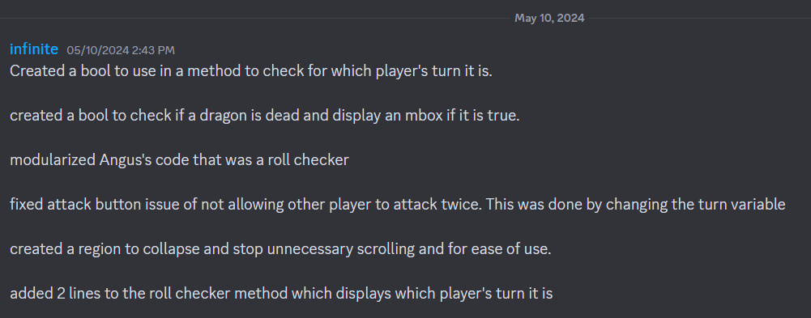

## Third and Fourth Build

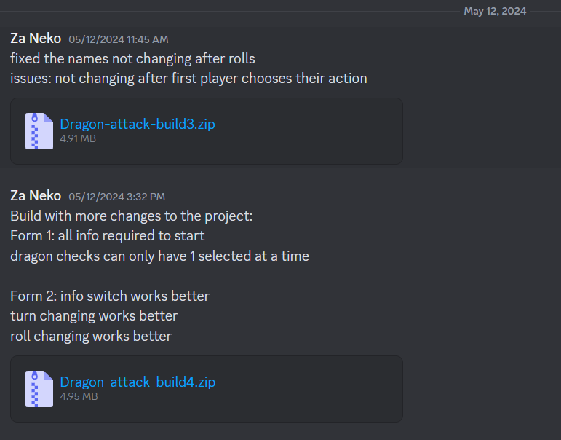

## Fifth Build

